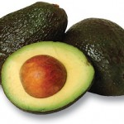

[Avocados!](http://nicholasdepacemd.burtoniaconsulting.com/avocados/)

[Edit](http://nicholasdepacemd.burtoniaconsulting.com/wp-admin/post.php?post=1596&action=edit)

“The fat that is in an avocado is monounsaturated fat, which is the good fats and heart healthy fat.” Are…

[Read more](http://nicholasdepacemd.burtoniaconsulting.com/avocados/)

<div class="wellnessBOX">

<div class="wellnessBOX01">

</div>

<div class="wellnessBOX02">

</div>

<div class="wellnessBOX03">

</div>

<div class="wellnessBOX04">

[ic_add_posts category='wellness' showposts='3']

</div>

</div>